Factor Analysis

Notes
Output Created |  | 28-JUN-2021 13:54:33
Comments
Input | Active Dataset | DataSet45
Input | Filter | <none>
Input | Weight | <none>
Input | Split File | <none>
Input | N of Rows in Working Data File | 92
Missing Value Handling | Definition of Missing | MISSING=EXCLUDE: User-defined missing values are treated as missing.
Missing Value Handling | Cases Used | LISTWISE: Statistics are based on cases with no missing values for any variable used.
Syntax |  | FACTOR  /VARIABLES ZConfirmed ZDeaths ZRecovered  /MISSING LISTWISE  /ANALYSIS ZConfirmed ZDeaths ZRecovered  /PRINT UNIVARIATE INITIAL CORRELATION EXTRACTION ROTATION  /FORMAT SORT  /PLOT EIGEN  /CRITERIA FACTORS(3) ITERATE(25)  /EXTRACTION PC  /CRITERIA ITERATE(25)  /ROTATION VARIMAX  /METHOD=COVARIANCE.
Resources | Processor Time | 00:00:00.27
Resources | Elapsed Time | 00:00:00.31
Resources | Maximum Memory Required | 1984 (1.938K) bytes

[DataSet45]

Descriptive Statistics
 | Mean | Std. Deviation | Analysis N
ZConfirmed | 1.71454066 | 1.000000016 | 91
ZDeaths | 1.83903000 | 1.000000628 | 91
ZRecovered | 1.75122967 | .999999645 | 91

Correlation Matrix
 |  | ZConfirmed | ZDeaths | ZRecovered
Correlation | ZConfirmed | 1.000 | .994 | .998
Correlation | ZDeaths | .994 | 1.000 | .998
Correlation | ZRecovered | .998 | .998 | 1.000

Communalities
 | Raw |  | Rescaled
 | Initial | Extraction | Initial | Extraction
ZConfirmed | 1.000 | 1.000 | 1.000 | 1.000
ZDeaths | 1.000 | 1.000 | 1.000 | 1.000
ZRecovered | 1.000 | 1.000 | 1.000 | 1.000

Extraction Method: Principal Component Analysis.

Total Variance Explained
 | Component | Initial Eigenvaluesª |  |  | Extraction Sums of Squared Loadings
 | Component | Total | % of Variance | Cumulative % | Total | % of Variance
Raw | 1 | 2.993 | 99.781 | 99.781 | 2.993 | 99.781
Raw | 2 | .006 | .208 | 99.988 | .006 | .208
Raw | 3 | .000 | .012 | 100.000 | .000 | .012
Rescaled | 1 | 2.993 | 99.781 | 99.781 | 2.993 | 99.781
Rescaled | 2 | .006 | .208 | 99.988 | .006 | .208
Rescaled | 3 | .000 | .012 | 100.000 | .000 | .012

Total Variance Explained
 | Component | Extraction Sums of Squared Loadingsª | Rotation Sums of Squared Loadings
 | Component | Cumulative % | Total | % of Variance | Cumulative %
Raw | 1 | 99.781 | 1.502 | 50.059 | 50.059
Raw | 2 | 99.988 | 1.498 | 49.920 | 99.978
Raw | 3 | 100.000 | .001 | .022 | 100.000
Rescaled | 1 | 99.781 | 1.502 | 50.059 | 50.059
Rescaled | 2 | 99.988 | 1.498 | 49.920 | 99.978
Rescaled | 3 | 100.000 | .001 | .022 | 100.000

Extraction Method: Principal Component Analysis.
a. When analyzing a covariance matrix, the initial eigenvalues are the same across the raw and rescaled solution.

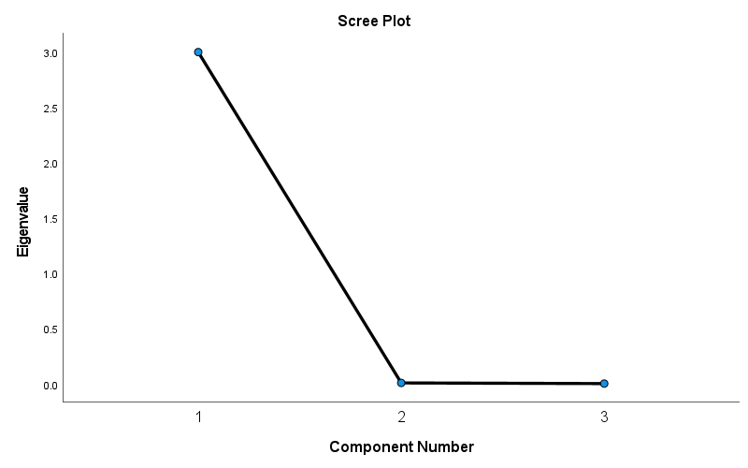

Component Matrixª
 | Raw |  |  | Rescaled
 | Component |  |  | Component
 | 1 | 2 | 3 | 1 | 2 | 3
ZRecovered | 1.000 | -.001 | -.015 | 1.000 | -.001 | -.015
ZDeaths | .998 | -.055 | .008 | .998 | -.055 | .008
ZConfirmed | .998 | .056 | .007 | .998 | .056 | .007

Extraction Method: Principal Component Analysis.ª
a. 3 components extracted.

Rotated Component Matrixª
 | Raw |  |  | Rescaled
 | Component |  |  | Component
 | 1 | 2 | 3 | 1 | 2 | 3
ZDeaths | .746 | .666 | .002 | .746 | .666 | .002
ZRecovered | .708 | .706 | .025 | .708 | .706 | .025
ZConfirmed | .667 | .745 | .003 | .667 | .745 | .003

Extraction Method: Principal Component Analysis.
Rotation Method: Varimax with Kaiser Normalization.ª
a. Rotation converged in 3 iterations.

Component Transformation Matrix
Component | 1 | 2 | 3
1 | .708 | .707 | .010
2 | -.707 | .708 | .000
3 | .007 | .007 | -1.000

Extraction Method: Principal Component Analysis.
Rotation Method: Varimax with Kaiser Normalization.

